In some cases, you don't want to tell a more extensive story.

For example, if someone asks you for a quick update.

Then just want to be clear & to-the-point.

﻿﻿

Then, the Pyramid Principle is a useful framework.

﻿﻿

### **Pyramid Principle - what is it?**

* Start with the most important part first.
* Then, with the arguments.
* And finally, more details and supporting data.

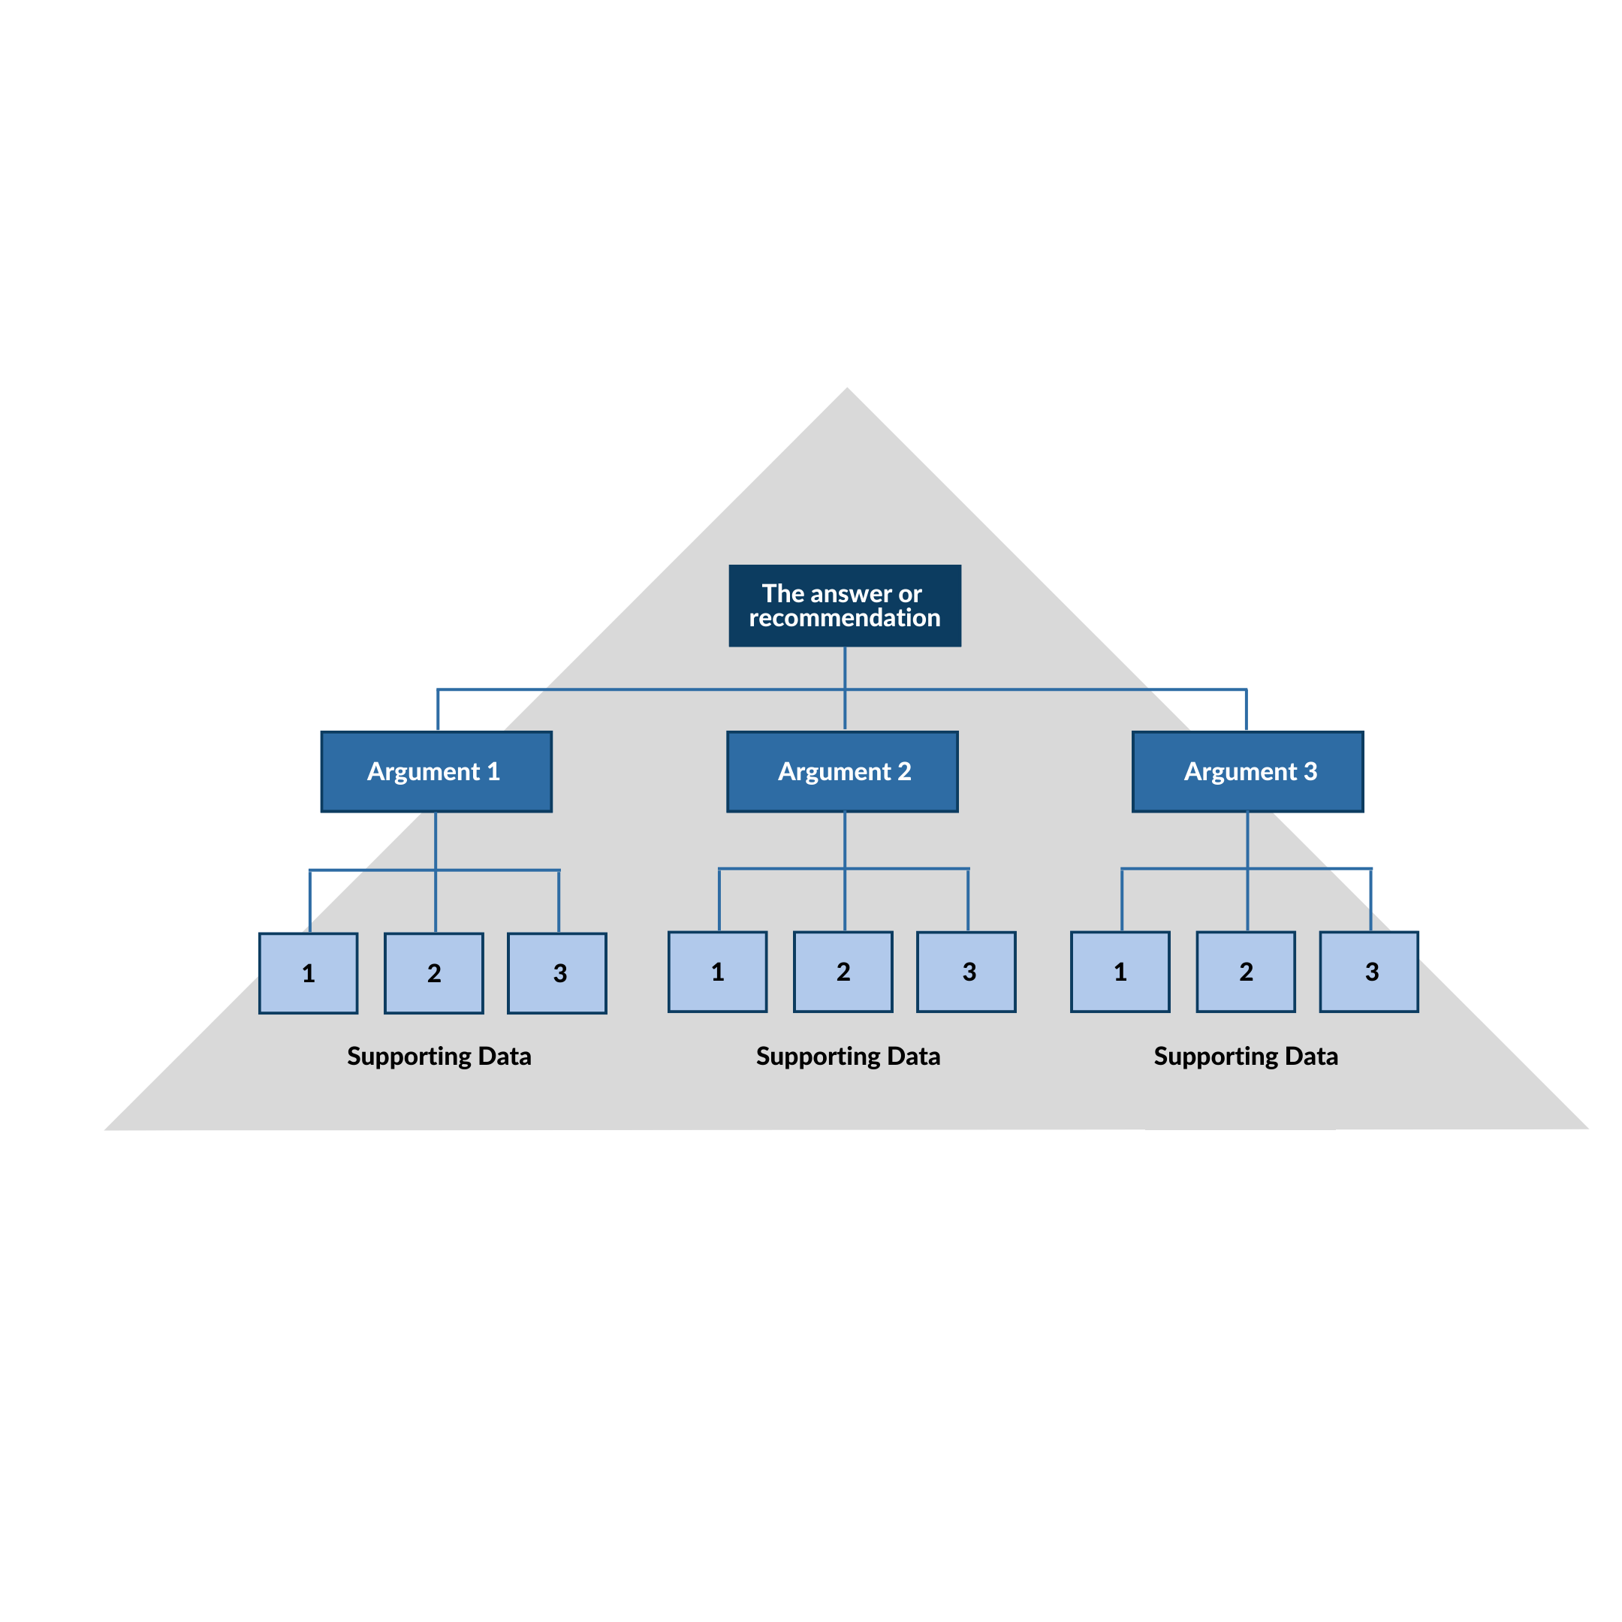  
﻿﻿

**Let's start with a super simple example.**

If my girlfriend asks: "What time will you be home for dinner?”

I could say:

“Well, I have to finish some last work, have to pick up my running shoes from the store, and then bring the spare key to Bob. So I'll be home around 7pm"

But if I answer this way, my girlfriend will become impatient and until she finally hears the answer she was looking for: 7pm.

If we'd answer with the pyramid principle, we'd start with the most important part first (what they need to know).

So I say: 7 PM. And then tell them the things I still need to do (if that's intereting to them).

﻿﻿

﻿﻿

**Now, a business example**

Imagine your manager asking: what's the **status** of your project?

﻿﻿

**Then you can say:**

It's quite difficult, because the data wasn't available. One of the stakeholders was on holiday. Getting feedback took longer. Also we had some data quality issues. So the project will be delayed.

Lot of rambling.

Hard to follow.

﻿﻿

**Here's how you answer with the Pyramic Principle:**

Unfortunately, the project will be delayed.

First, the data wasn't available.

Second, one of the stakeholders was on holiday. Getting feedback took longer.

Third, we had some data quality issues.

﻿﻿

**﻿﻿**

**That's how you use the Pyramid Principle in practice.**

Not great tool if you want to tell stories, and when it's difficult to persuade people.

However, it's a useful framework for concise communication.

Try it out.

﻿﻿

﻿﻿

